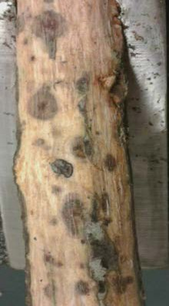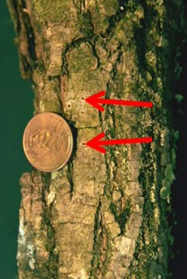THOUSAND CANKERS DISEASE and WALNUT TWIG BEETLE
Identification Guide

Walnut twig beetle attacks only species of Juglans; the fungus, Geosmithia morbida, is transported by walnut twig beetle
Field diagnosis: Flagging/yellowing foliage, leaf wilt, canopy thinning, branch dieback, epicormic shoots

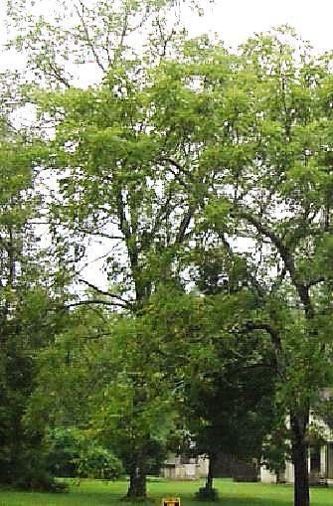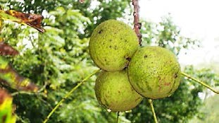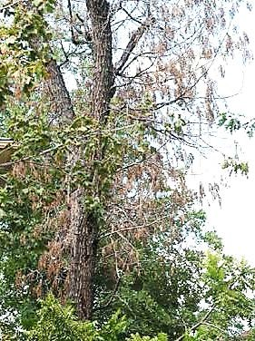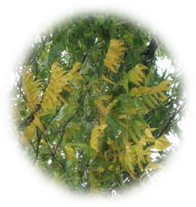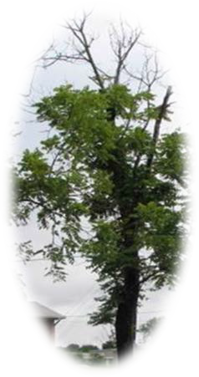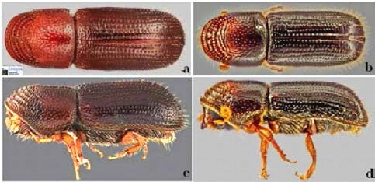

Adult walnut twig beetle: a) female - dorsal view, b) male - dorsal view,
c) female - lateral view, and d) male - lateral view (Photos: S. Valley, Valley, Oregon Dept. Agric).
For more information visit: www.tcdgroundzero.com

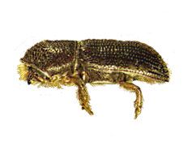Walnut twig beetle
(Pityophthorus juglandis)

Life cycle of walnut twig beetle
Adults emerge in spring; seek feeding sites on the bark, where they enter and form galleries as they feed. Beetles deposit conidia and the fungus grows within the galleries forming small cankers.

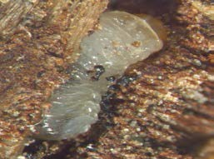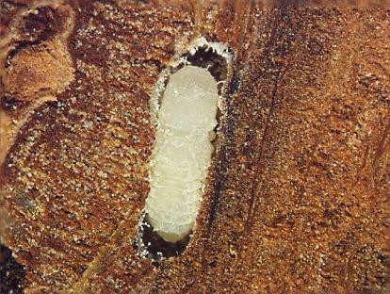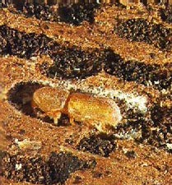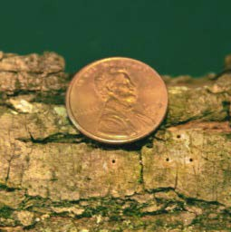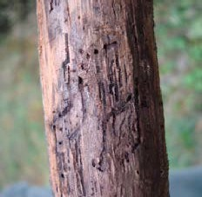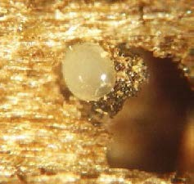Entrance hole Beetle galleries Egg in gallery Larva in gallery Pupa in gallery Teneral adult

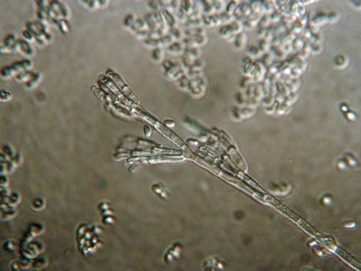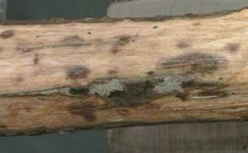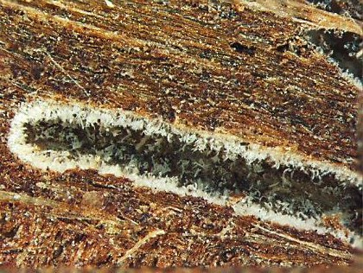Fungal development in black walnut
Fungus in beetle gallery Geosmithia conidia Fungal cankers

Funding for this pamphlet was provided by the U.S. Department of Agriculture.

